**Calculating Family Expenses using ServiceNow**

**Project Title : Calculating family expenses using service now**

**Team ID:NM2025TMID15609**

**Team Size: 4**

**Team** **Leader: Jyothika Kottu**

**Team Member: Lavanya Tuthika**

**Team Member: Kamadi Sowmya Sri**

**Team Member: Kadimi Santhosh Vardhan**

**Problem Statement:**

There is currently no efficient system in place to track, categorize, and analyze family expenses in a way that is integrated, automated, and accessible in real-time. This leads to poor budget planning, missed payments, overspending, and a lack of financial visibility.

**Objective:**

To design and implement a solution using **ServiceNow** that allows family members to:

1. **Input and categorize expenses** easily via a user-friendly interface or mobile portal.
2. **Automate recurring expenses** (e.g., rent, subscriptions).
3. **Track total and category-wise spending** on a monthly/weekly basis.
4. **Set spending limits and receive alerts** when thresholds are crossed.
5. **Generate reports and dashboards** to visualize trends and support better financial decisions.
6. **Share visibility and responsibilities** across family members via roles or user groups.

**Skills:**

* **ServiceNow App Development** (App Engine Studio)
* **Custom Tables & Data Modeling**
* **Form Design & UI Customization**
* **Flow Designer** (for automation)
* **Business Rules & Scripting**
* **Reporting & Dashboards**
* **User Roles & Access Control (ACLs)**

**TASK INITIATION**

**Milestone 1 : Instance**

**Activity 1: Setting up ServiceNow instance**

1. Sign up for a developer account on the ServiceNow Developer site “https://developer.servicenow.com”.
2. Once logged in, navigate to the "Personal Developer Instance" section.
3. Click on "Request Instance" to create a new ServiceNow instance.
4. Fill out the required information and submit the request.
5. You'll receive an email with the instance details once it's ready.
6. Log in to your ServiceNow instance using the provided credentials.
7. Now you will navigate to the ServiceNow.

### 

### Milestone 2:New Update Set

### Activity 1: Creation of New Update Set

1. Go to All >>In the filter search for Local Update set > click on New.

2. Enter the Details as:

Name : Family Expenses

3. Then click on Submit and Make current.

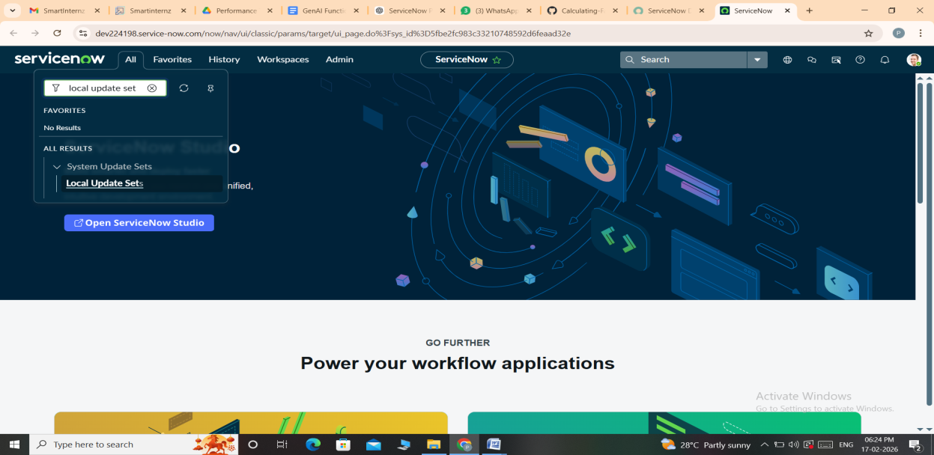

### Screenshot (66).png

### Milestone 3: Table(Family Expenses)

### Activity 1: Creation of Family Expenses Table

1. Go to All >In the filter search for Tables > click on New.
2. Enter the Details:

Label : Family Expenses

Name : Auto-Populated

New menu name : Family Expenditure

3. Go to the Header and right click there>> click on Save.

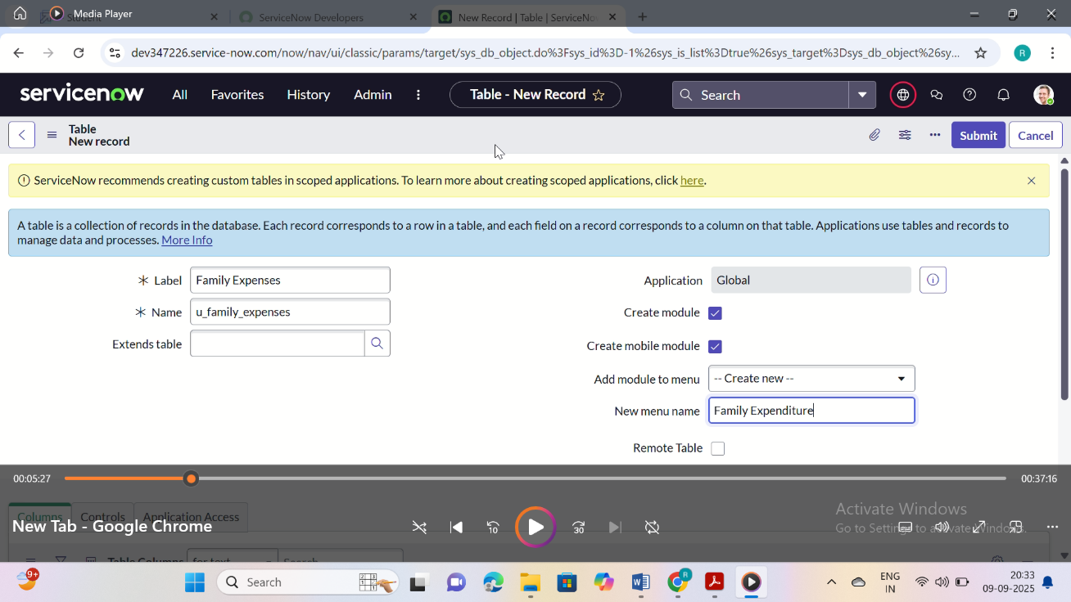

### Activity 2: Creation of Family Expenses Table

1. Near Columns Double click near insert a new row.
2. Give the details as:

Column label : Number

Type : String

3. Double click on insert a new row again.

4. Give the details as:

Column label : Date

Type : Date

5. Double click on insert a new row again

6. Give the details as:

Column label : Amount

Type : Integer

7. Double click on insert a new row again

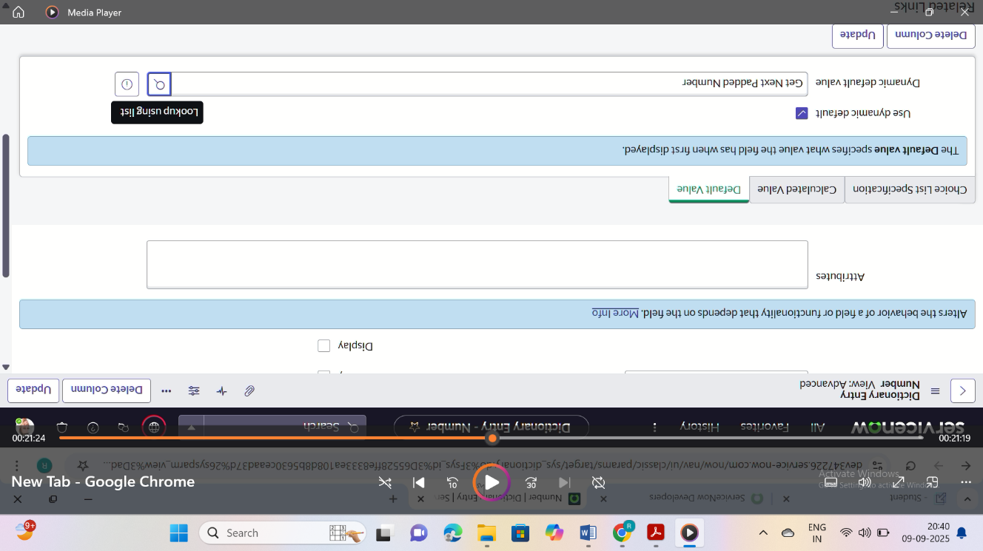8. Give the details as:

Column label : Expense Details

Type : String

Max length : 800

9. Go to the Header and right click there>> click on Save.

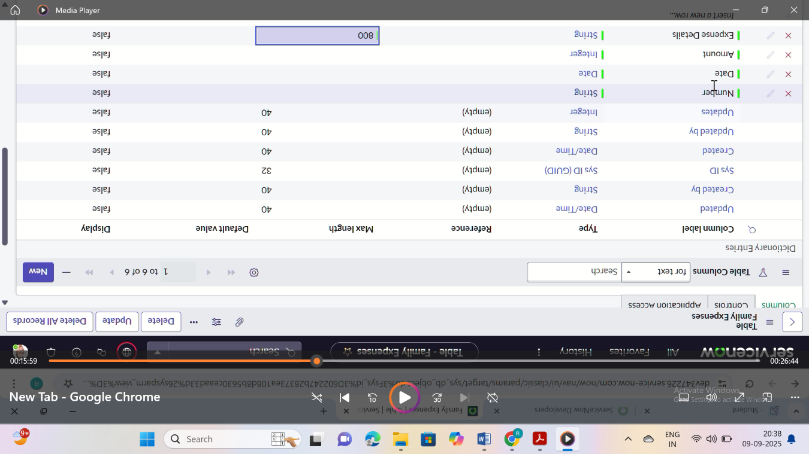

### Activity 3: Making Number Field an Auto-Number

1. Double click on the Number Field/Column.
2. Go down and double click on Advanced view
3. In Default Value:

Use dynamic default : check the box

Dynamic default value : Get Next Padded Number

4. Click on Update.

5. Go to All >>In the filter search for Number Maintenance >> select Number Maintenance

6. Click on New.

7. Enter the below Details:

Table : Family Expenses

Prefix : MFE

8. Click on Submit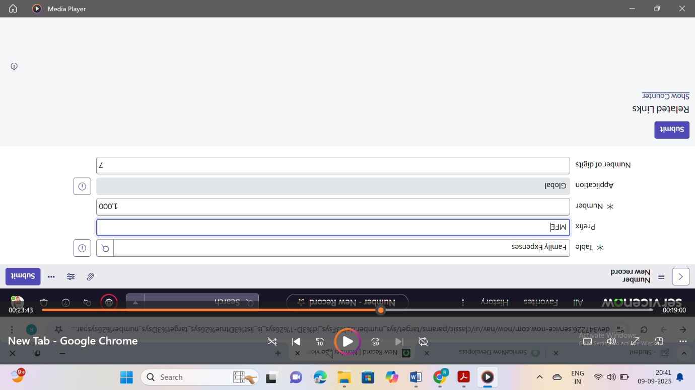

**Activity 4:Configure the Form**

1. Go to All >> In the filter search for Family Expenses >> Open Family Expenses
2. Click on New
3. Go to the Header and right click there>> click on Configure >> Select Form Design
4. Customize or Drag Drop the form as per your requirement.

5. Make Number Read-Only Field by clicking on the gear icon and checking Read-Only

6. Make Date, Amount Mandatory Field by clicking on the gear icon and checking Mandatory

7. Click on Save.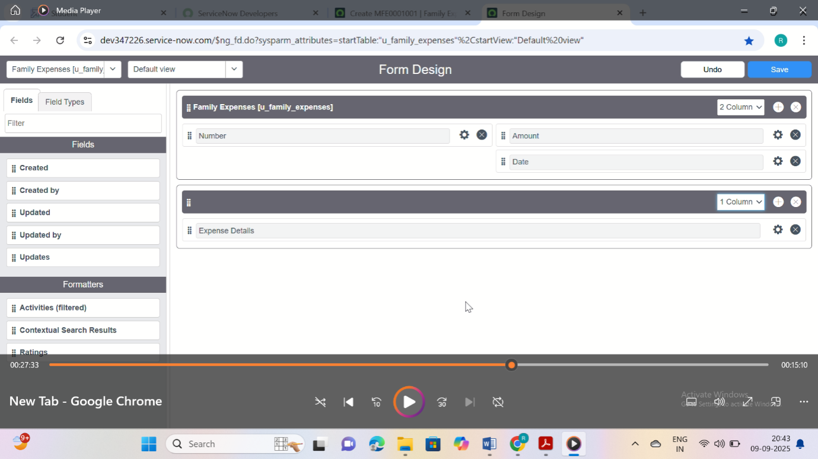

### Milestone 4: Table(Daily Expenses)

### Activity 1: Creation ofTable(Daily Expenses)

1. Go to All >In the filter search for Tables > click on New.
2. Enter the Details:

Label : Daily Expenses

Name : Auto-Populated

Add Module to menu : Family Expenditure

3. Go to the Header and right click there>> click on Save.

### Activity 2: Creation of Columns(Fields)

1. 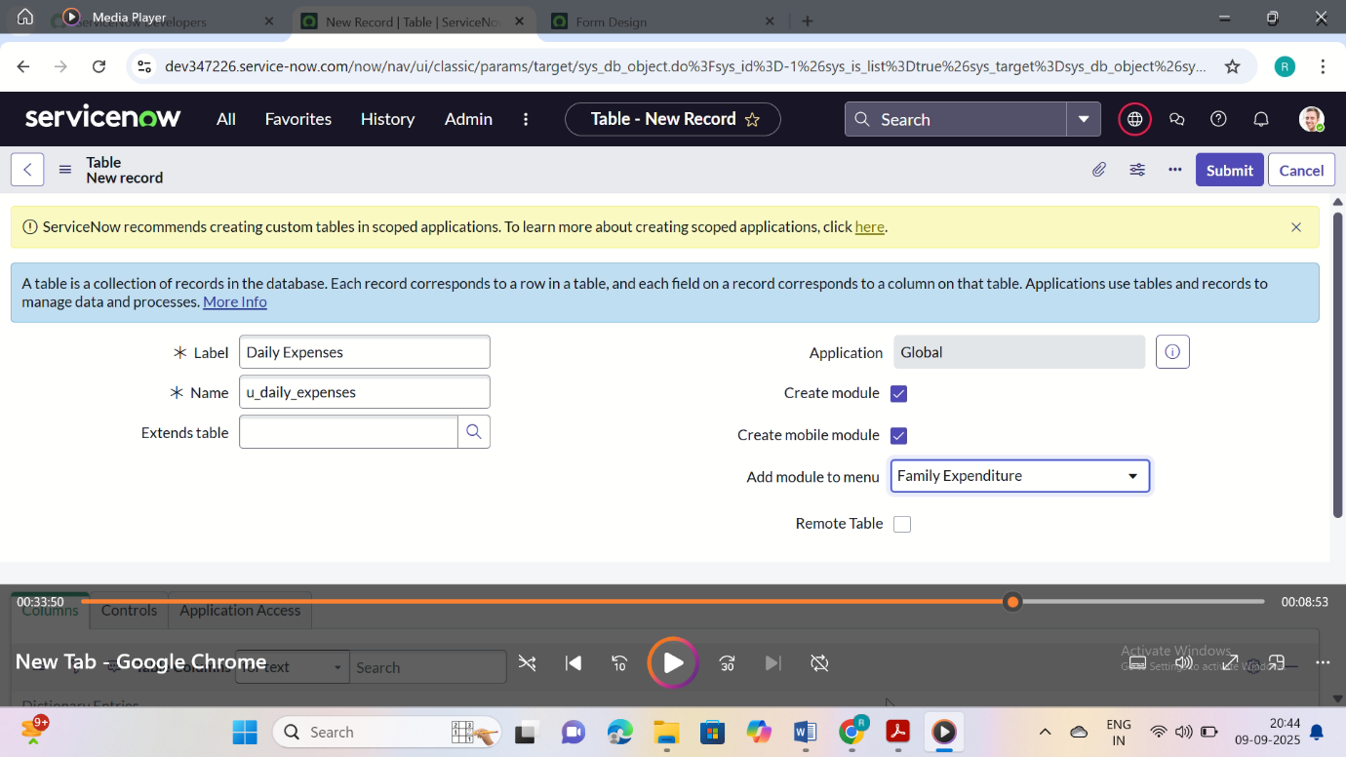Near Columns Double click near insert a new row.
2. Give the details as:

Column label : Number

Type : String

3. Double click on insert a new row again

4. Give the details as:

Column label : Date

Type : Date

5. Double click on insert a new row again

6. Give the details as:

Column label : Expense

Type : Integer

7. Double click on insert a new row again

8. Give the details as:

Column label : Family Member Name

Type : Reference

Max length : 800

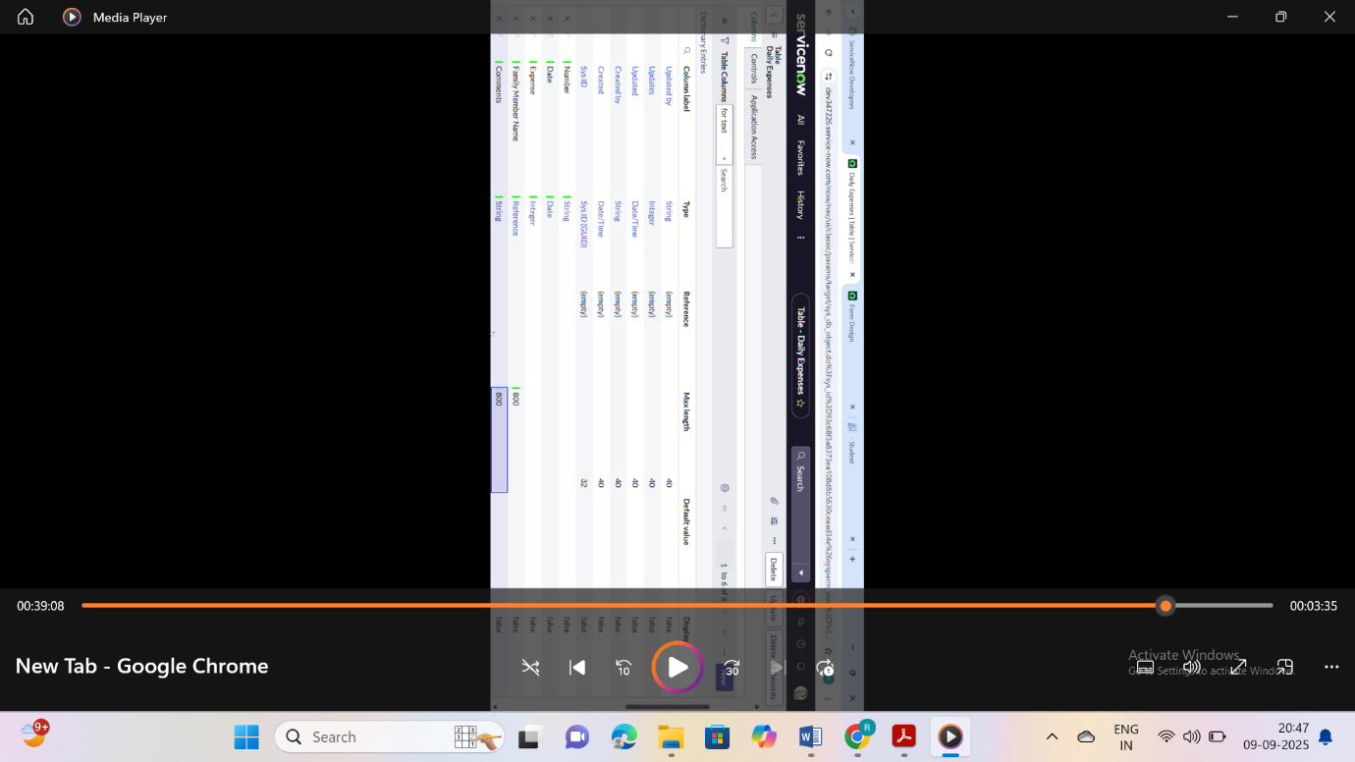

9. Double click on insert a new row again

10. Give the details as:

Column label : Comments

Type : String

Max length : 800

11. Go to the Header and right click there>> click on Save.

### Activity 3: Making Number Field an Auto-Number

1. Double click on the Number Field/Column.

2. Go down and double click on Advanced view

3. In Default Value:

Use dynamic default : check the box

Dynamic default value : Get Next Padded Number

4. Click on Update.

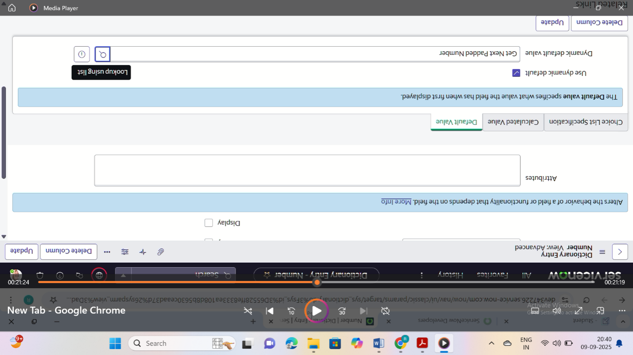

5. Go to All >>In the filter search for Number Maintenance >> select Number Maintenance

6. Click on New.

7. Enter the below Details:

Table : Daily Expenses

Prefix : DFE

8. Click on Submit.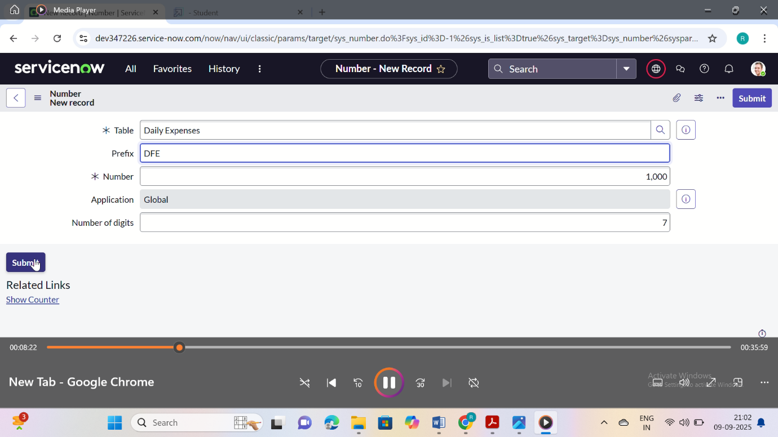

### Activity 4: Configure the Form

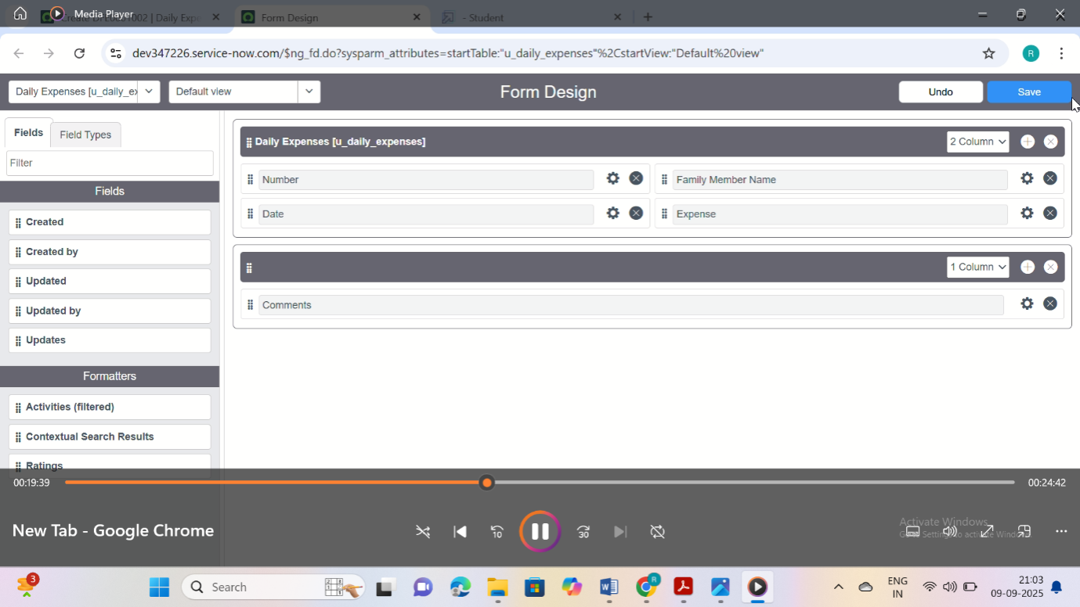 1. Go to All >>In the filter search for Daily Expenses >> Open Daily Expenses

2. Click on New

3. Go to the Header and right click there>> click on Configure >> Select Form Design

4. Customize or Drag Drop the form as per your requirement.

5. Make Number Read-Only Field by clicking on the gear icon and checking Read-Only

6. Make Date, Family Member Name Mandatory Field by clicking on the gear icon and checking Mandatory

7. Click on Save.

### Milestone 5: Creation of Relationship

### Activity 1: Creation of Relationship between Family Expenses and Daily Expenses tables

1. Go to All >> In the filter search for Relationships >> Open Relationships
2. Click on New.
3. Enter the details:

Name : Daily Expenses

Applies to table : Select Family Expenses

Daily Expenses : Select Daily Expenses

4. Click Save.

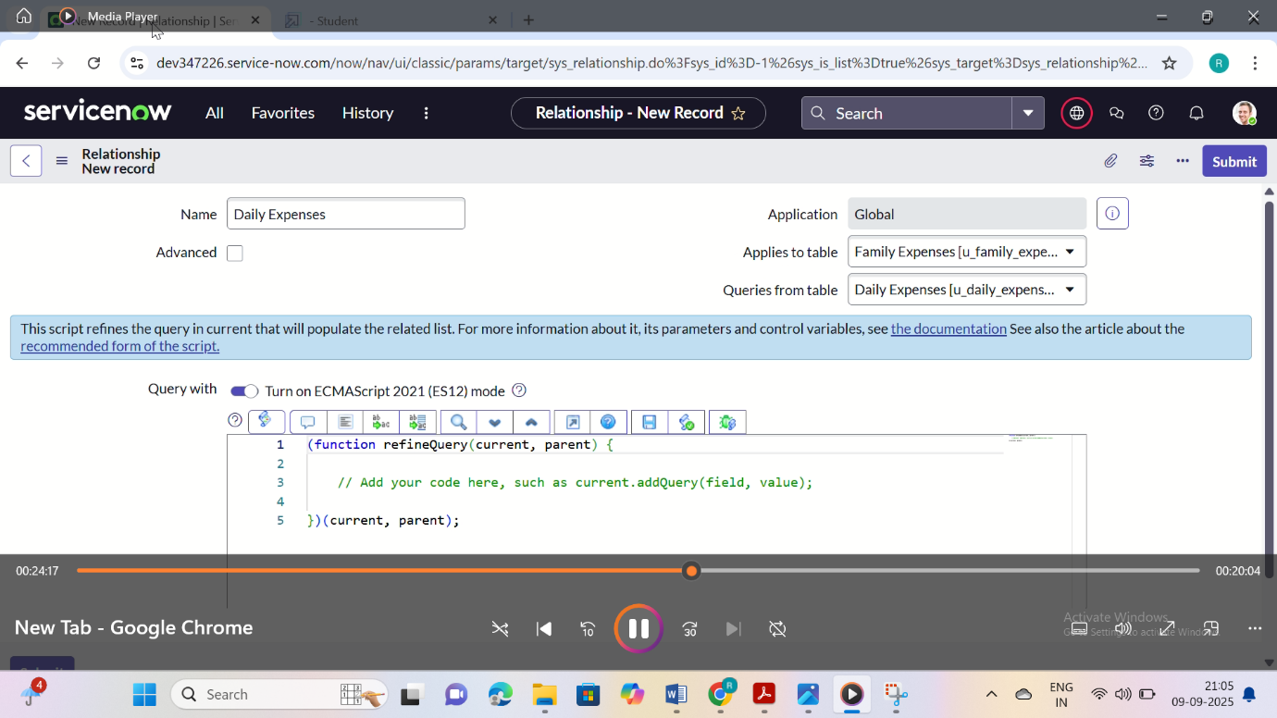

### Milestone 6: Configuring Related List on Family Expenses

### Activity 1: Configuring Related List on Family Expenses

1. Go to All >> In the filter search for Family Expenses >> Open Family Expenses
2. Click on New
3. Go to the Header and right click there>> click on Configure >> Select Related Lists
4. Add Daily Expenses to the Selected Area.
5. Click on Save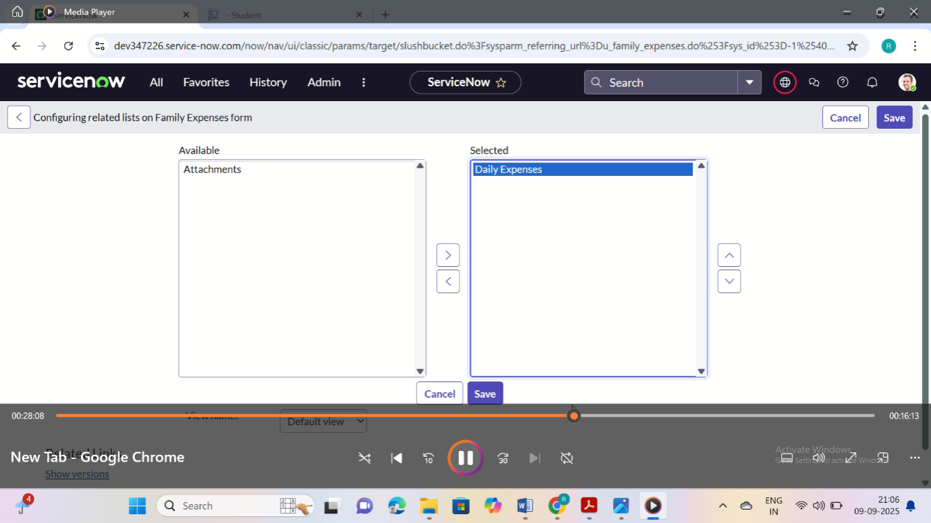

### Milestone 7: Business Rules

### Activity 1: Creation of Business Rules

1. Go to All >>In the filter search for Business Rules.
2. Under System Definition Select Business Rules then click on New.
3. Enter the Details:

Name : Family Expenses BR

Table : Select Daily Expenses

Check Advanced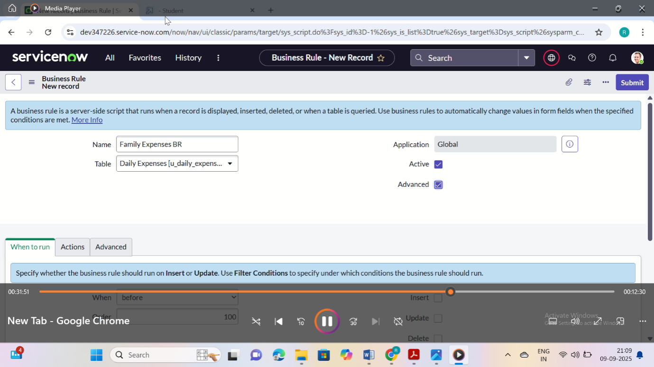

4. In when to run Check Insert and Update

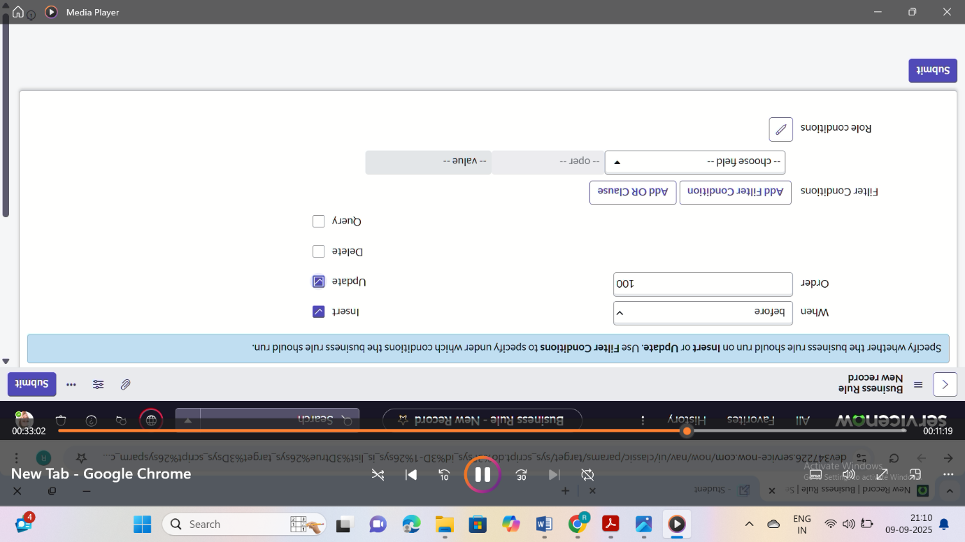

5. In Advance(we write the code): Write the below code >>

(functionexecuteRule(current, previous /*null when async*/) {

varFamilyExpenses = new GlideRecord('u_family_expenses');

FamilyExpenses.addQuery('u_date',current.u_date);

FamilyExpenses.query();

if(FamilyExpenses.next())

{

FamilyExpenses.u_amount += current.u_expense;

FamilyExpenses.u_expense_details += ">"+current.u_comments+":"+"Rs."+current.u_expense+"/-";

FamilyExpenses.update();

}

else

{

varNewFamilyExpenses = new GlideRecord('u_family_expenses');

NewFamilyExpenses.u_date = current.u_date;

NewFamilyExpenses.u_amount = current.u_expense;

NewFamilyExpenses.u_expense_details += ">"+current.u_comments+":"+"Rs."+current.u_expense+"/-";

NewFamilyExpenses.insert();

}

})(current, previous);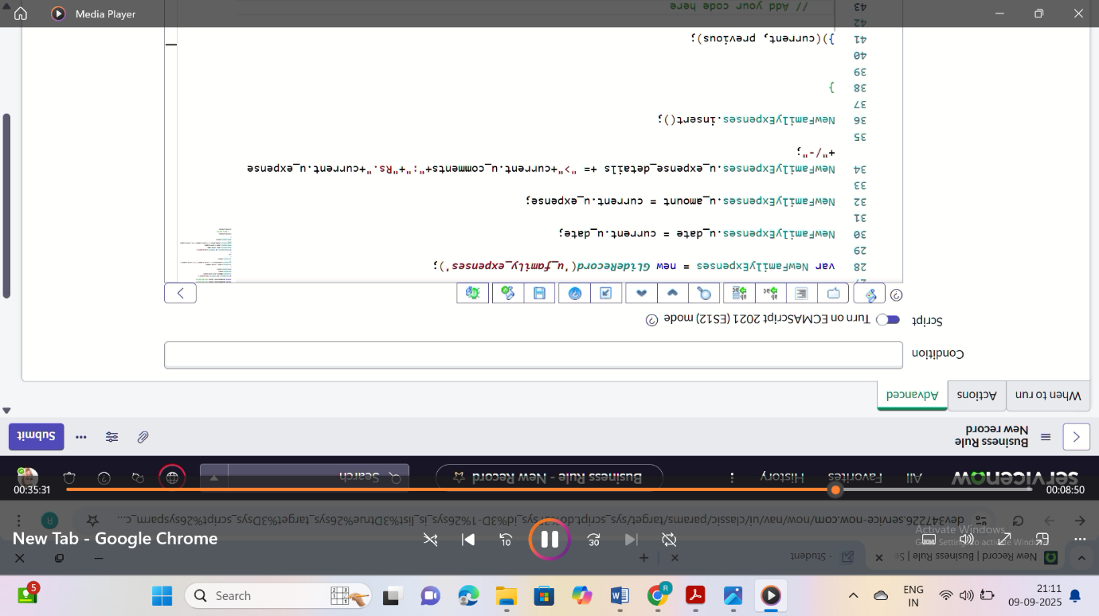

6. Go to the Header and right click there>> click on Save.

### Milestone 8: Relationship

### Activity 1: Configure the Relationship

1. Go to All >>In the filter search for Relationships >> Open Relationships.
2. In that, open Daily Expenses Relationship.
3. For Applies to table : Select Family Expenses.
4. In Query with : write the below Query.

(functionrefineQuery(current, parent) {

// Add your code here, such as current.addQuery(field, value);

current.addQuery('u_date',parent.u_date);

current.query();

})(current, parent);

5. Click on Update.